**CricketApp:**

**App.js:**

import React from "react";

import ListofPlayers from "./ListofPlayers";

import Scorebelow70 from "./Scorebelow70";

import { OddPlayers } from "./OddPlayers";

import { EvenPlayers } from "./EvenPlayers";

import ListofIndianPlayers from "./ListofIndianPlayers";

import { players, IndianTeam, IndianPlayers } from "./data";

function App() {

  const flag = false; // Change to false to show Indian Players

  if (flag === true) {

    return (

      <div>

        <h1>List of Players</h1>

        <ListofPlayers players={players} />

        <hr />

        <h1>List of Players having Scores Less than 70</h1>

        <Scorebelow70 players={players} />

      </div>

    );

  } else {

    return (

      <div>

        <h1>Indian Team</h1>

        <h2>Odd Players</h2>

        {OddPlayers(IndianTeam)}

        <hr />

        <h2>Even Players</h2>

        {EvenPlayers(IndianTeam)}

        <hr />

        <h1>List of Indian Players Merged:</h1>

        <ListofIndianPlayers IndianPlayers={IndianPlayers} />

      </div>

    );

  }

}

export default App;

**EvenPlayers.js:**

import React from "react";

export function EvenPlayers([, second, , fourth, , sixth]) {

  return (

    <div>

      <li>Second : {second}</li>

      <li>Fourth : {fourth}</li>

      <li>Sixth : {sixth}</li>

    </div>

  );

}

**data.js:**

export const players = [

  { name: "Jack", score: 50 },

  { name: "Michael", score: 70 },

  { name: "John", score: 40 },

  { name: "Ann", score: 61 },

  { name: "Elisabeth", score: 61 },

  { name: "Sachin", score: 95 },

  { name: "Dhoni", score: 100 },

  { name: "Virat", score: 84 },

  { name: "Jadeja", score: 64 },

  { name: "Raina", score: 75 },

  { name: "Rohit", score: 80 },

];

export const IndianTeam = [

  "Sachin1",

  "Dhoni2",

  "Virat3",

  "Rohit4",

  "Yuvaraj5",

  "Raina6",

];

const T20Players = ["First Player", "Second Player", "Third Player"];

const RanjiTrophyPlayers = ["Fourth Player", "Fifth Player", "Sixth Player"];

export const IndianPlayers = [...T20Players, ...RanjiTrophyPlayers];

**ListofIndianPlayers.js:**

import React from "react";

const ListofIndianPlayers = ({ IndianPlayers }) => {

  return (

    <ul>

      {IndianPlayers.map((player, index) => (

        <li key={index}>Mr. {player}</li>

      ))}

    </ul>

  );

};

export default ListofIndianPlayers;

**ListofPlayers.js:**

import React from "react";

const ListofPlayers = ({ players }) => {

  return (

    <ul>

      {players.map((item, index) => (

        <li key={index}>

          Mr. {item.name} <span>{item.score}</span>

        </li>

      ))}

    </ul>

  );

};

export default ListofPlayers;

**OddPlayers.js:**

import React from "react";

export function OddPlayers([first, , third, , fifth]) {

  return (

    <div>

      <li>First : {first}</li>

      <li>Third : {third}</li>

      <li>Fifth : {fifth}</li>

    </div>

  );

}

**Scorebelow70.js:**

import React from "react";

const Scorebelow70 = ({ players }) => {

  const filtered = players.filter((item) => item.score < 70);

  return (

    <ul>

      {filtered.map((item, index) => (

        <li key={index}>

          Mr. {item.name} <span>{item.score}</span>

        </li>

      ))}

    </ul>

  );

};

export default Scorebelow70;

**OUTPUT:**

FALSE:

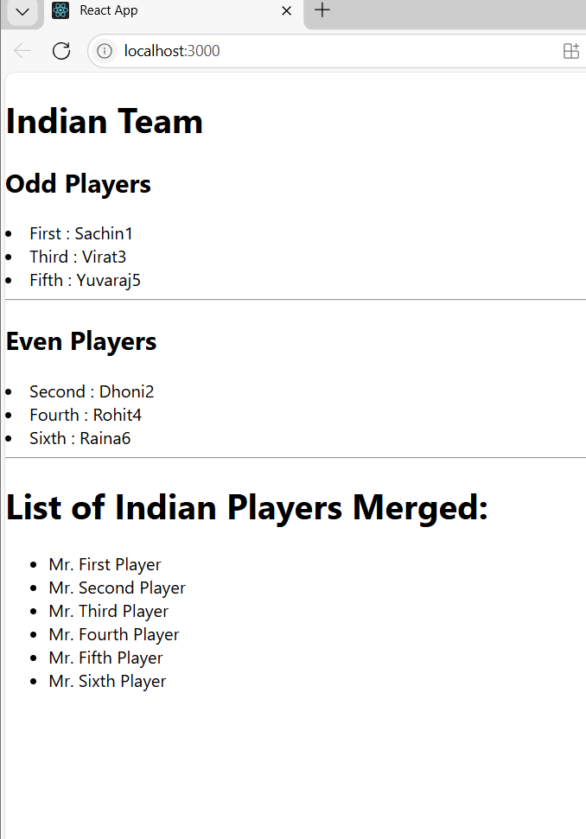

TRUE:

